# [LAW & ORDER’s Rick Eid on Co-Writing ‘Gimme Shelter’: ‘We Threw Format Out the Window’ for the Franchise-First Crossover](https://www.givememyremote.com/remote/2022/09/20/law-and-order-crossover-writer-rick-eid/)

September 20, 2022 by [Marisa Roffman](https://www.givememyremote.com/remote/author/marisa/)

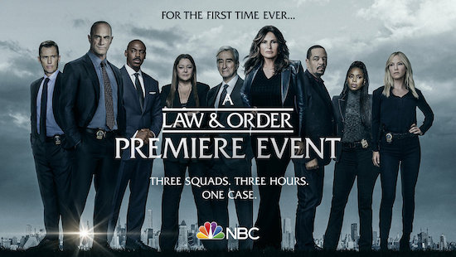

***LAW & ORDER CROSSOVER — Pictured: “Law & Order Crossover” Key Art — (Photo by: NBC)***

The LAW & ORDER franchise has one of its biggest events yet on Thursday, September 22 (at 8/7c), as LAW & ORDER, LAW & ORDER: SPECIAL VICTIMS UNIT, and LAW & ORDER: ORGANIZED CRIME [collide for “Gimme Shelter.”](https://www.givememyremote.com/remote/2022/09/08/law-order-crossover-promo-gimme-shelter-video/) (For one night only, OC will kick off the night, followed by SVU, and concluding with the mothership; the title sequence and complete credits for the three-hour event will air in during the first part.)

In the crossover, a young girl is killed, leading LAW & ORDER’s Detective Frank Cosgrove ([Jeffrey Donovan](https://www.givememyremote.com/remote/2022/09/15/law-and-order-season-22-spoilers-rick-eid/)) to team up with new-to-the-franchise Detective Jalen Shaw ([Mehcad Brooks](https://www.givememyremote.com/remote/2022/08/26/law-and-order-detective-jalen-shaw-mehcad-brooks-rick-eid/)) to get to the bottom of the murder. But, naturally, “the case begins to escalate and morph into something different,” LAW & ORDER boss—and “Gimme Shelter” co-writer—[Rick Eid](https://www.givememyremote.com/remote/2022/05/18/law-and-order-season-21-finale-preview-rick-eid-eriq-la-salle/) teases to [Give Me My Remote](https://www.givememyremote.com/remote/). “So we bring all of our resources to bear on this one case.”

As a result, rather than the crossovers of the past, “the characters are more seamlessly integrated” across the three hours, he notes. “It’s not a hand off to another show and then that show hands off to the next show. It’s really just one story that involves all the characters of all the shows.”

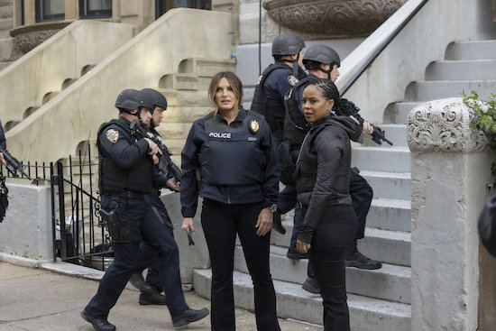

***LAW & ORDER: ORGANIZED CRIME — “Lost One” Episode 220 — Pictured: (l-r) Mariska Hargitay as Captain Olivia Benson, Danielle Moné Truitt as Sgt. Ayanna Bell — (Photo by: Eric Liebowitz/NBC)***

Under normal circumstances, the three shows vary greatly in how they tell stories: LAW & ORDER spends half the episode on the investigation and the other half on the legal case; ORGANIZE CRIME is more serialized, [taking on longer arcs](https://www.givememyremote.com/remote/2022/08/24/law-and-order-organized-crime-season-3-spoilers-bryan-goluboff/); SVU is episodic, but flexible with structure.

But because the event was so interconnected, they took a new approach to achieve a consistent tone across the three hours. “We had Jean de Segonzac, who has been around the Wolf universe for a long time, and [directed the first episode we did to relaunch LAW & ORDER](https://www.givememyremote.com/remote/2022/02/08/law-and-order-season-21-premiere-time/)—and he’s directed all the different LAW & ORDERs—direct two out of the three hours,” Eid says. “We manipulated the schedule [of filming the crossover] so he could direct two out of the three hours [OC and SVU, which filmed first and third in production]. And then the third hour [which was filmed second] was directed by Alex Hall, who’s the director-producer for LAW & ORDER. So we brought in our ringers to create some continuity here.”

To fuse the worlds together, “we threw format out the window,” Eid acknowledges. “You’ll recognize it, there’s still a crime, and you’ll hear the [*mimics the “dun dun” sound*], but it’s a special event that will incorporate all of our favorite characters on these shows…It’s such a long script [for the three episodes]—I think it was 148-pages or something like that; it was crazy.”

Having to combine the worlds, however, was easier said than done. “It’s hard to incorporate every single character [an equal amount]…there’s scheduling issues and financial issues; there’s a lot of issues that go into all that. ” Eid says. “Clearly we wanted to make sure that the most prominent characters are featured most prominently. And that that is definitely the case.”



***LAW & ORDER: ORGANIZED CRIME — “Takeover” Episode 215 — Pictured: (l-r) Christopher Meloni as Detective Elliot Stabler, Mariska Hargitay as Captain Olivia Benson — (Photo by: Virginia Sherwood/NBC)***

For Eid, there was also an extra hurdle: While [he’s running LAW & ORDER](https://www.givememyremote.com/remote/2022/05/04/law-and-order-severance-spoilers-rick-eid/) and spent a season as SVU’s showrunner, he never wrote for the ORGANIZED CRIME characters; his co-writer, [Gwen Sigan](https://www.givememyremote.com/remote/2022/04/13/chicago-pd-voight-anna-jason-beghe-gwen-sigan/) (who [runs CHICAGO P.D.](https://www.givememyremote.com/remote/2022/09/19/chicago-pd-season-10-spoilers-voight-halstead-upton-gwen-sigan/)), had never written for any of the shows in the franchise.

“I’ve never written Stabler, but [ORGANIZED CRIME star] [Chris Meloni](https://www.givememyremote.com/remote/2021/06/04/svu-organized-crime-benson-stabler-romance-mariska-hargitay-christopher-meloni/) knows that character way better than I do, and we’ve had a few conversations about certain scenes,” Eid shares. “When you get actors like Chris and [SVU star] [Mariska [Hargitay](https://www.givememyremote.com/remote/2021/04/02/mariska-hargitay-christopher-meloni-elliot-olivia-reunion-svu-organized-crime/)], they’re going to take the story elements, and the scene, and they’re going to find a way to make it specific to them, in a way that great actors do. We’re lucky to have people like that involved.”

“It made it so that we didn’t have to know *every* aspect of these characters, because *they* did,” he continues. “TV really is a collaborative medium—it takes everybody involved because of how tight the schedule is and how fast everything moves. Everybody’s got to chip in and those guys were great collaborators throughout the whole process.”

Helping—and yet also making matters more complicated—is the fact the crossover is “a special event, and it kind of exists in its own universe”…but also has to introduce new LAW & ORDER regular Brooks to the franchise *and* is kickstarting a storyline for another show’s upcoming season.

“Something definitely happens in the crossover that will affect one of the shows, so we talked about that [with their creative team] to make sure we were all on the same page, and that whatever we set up in the crossover would service what they intended to do for the season,” Eid previews. “We know it’s connected to the individual shows, but it’s kind of a unique beast.”

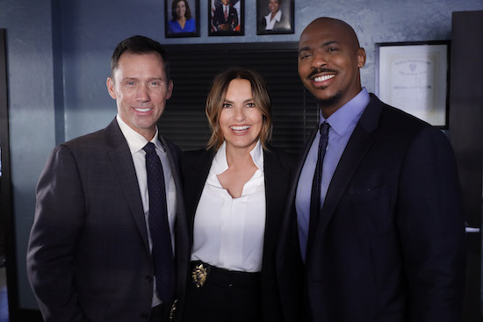

***LAW & ORDER: PREMIERE — “Gimme Shelter” — Pictured: (l-r) Jeffrey Donovan as Detective Frank Cosgrove, Mariska Hargitay as Captain Olivia Benson, Mehcad Brooks as Detective Jalen Shaw — (Photo by: Will Hart/NBC)***

Though they might not be able to pull off something quite to this scale again any time soon, Eid isn’t shutting the door on [LAW & ORDER hosting mini-crossovers](https://www.givememyremote.com/remote/2022/04/29/law-and-order-mariska-hargitay-terry-serpico-season-finale/) in the meantime.

“I think we’ll always think about it,” he says. “And if an episode presents an organic opportunity to bring a character over from one those shows, we’ll do it. We’re not starting out with, ‘We need three episodes that cross over’—at least I’m not. It’s always a really interesting thing to do, and I think it’s really cool to just incorporate the different elements of the universe. So, it’s something that’s always in the back of our minds as we’re breaking stories, and if an opportunity presents itself, I’d say we’ll probably see a, as you said, a mini crossover here or there this season.”

***LAW & ORDER Crossover, Thursday, September 22, 8/7c, NBC***

**RELATED:**

* [LAW & ORDER Crossover: Watch the Action-Packed First Footage From ‘Gimme Shelter’](https://www.givememyremote.com/remote/2022/09/08/law-order-crossover-promo-gimme-shelter-video/)
* [NBC Reveals LAW & ORDER Crossover Key Art](https://www.givememyremote.com/remote/2022/09/01/law-and-order-crossover-poster/)
* [LAW & ORDER: SPECIAL VICTIMS UNIT Boss Reveals Kelli Giddish’s Final Episode](https://www.givememyremote.com/remote/2022/08/29/law-and-order-svu-kelli-giddish-final-episode/)
* [Bryan Goluboff Teases How LAW & ORDER: ORGANIZED CRIME and SVU Will Dive Into Elliot and Olivia’s Time Apart—and Previews Their Future](https://www.givememyremote.com/remote/2022/08/29/organized-crime-elliot-olivia-relationship-svu-bryan-goluboff/)
* [LAW & ORDER’s Rick Eid: Mehcad Brooks’ Detective Shaw ‘Brings a Different Perspective to Law Enforcement’](https://www.givememyremote.com/remote/2022/08/26/law-and-order-detective-jalen-shaw-mehcad-brooks-rick-eid/)
* [LAW & ORDER: SPECIAL VICTIMS UNIT: Kelli Giddish to Exit in Season 24](https://www.givememyremote.com/remote/2022/08/24/law-and-order-svu-kelli-giddish-exit-season-24/)
* [LAW & ORDER: ORGANIZED CRIME is Shaking Up Its Format in Season 3](https://www.givememyremote.com/remote/2022/08/24/law-and-order-organized-crime-season-3-spoilers-bryan-goluboff/)
* [Behind-the-Scenes Photos and Videos from the LAW & ORDER Franchise Crossover](https://www.givememyremote.com/remote/2022/08/24/behind-the-scenes-photos-and-videos-from-the-law-order-franchise-crossover/)
* [NBC Confirms LAW & ORDER Crossover Event With New Promo](https://www.givememyremote.com/remote/2022/08/24/law-and-order-svu-organized-crime-crossover-event/)
* [6 Dream LAW & ORDER Franchise Crossover Pairings](https://www.givememyremote.com/remote/2022/07/14/6-dream-law-and-order-franchise-crossover-pairings/)
* [LAW & ORDER: ORGANIZED CRIME Adds Gus Halper and Camilla Belle](https://www.givememyremote.com/remote/2022/08/12/law-order-organized-crime-gus-halper-camilla-belle/)
* [LAW & ORDER: SPECIAL VICTIMS UNIT Scoop: Molly Burnett to Recur](https://www.givememyremote.com/remote/2022/07/26/law-and-order-svu-molly-burnett-grace-muncy/)
* [LAW & ORDER: ORGANIZED CRIME Adds Rick Gonzalez and Brent Antonello](https://www.givememyremote.com/remote/2022/07/29/law-and-order-organized-crime-season-3-cast-rick-gonzalez-brent-antonello-nona-parker-johnson/)
* [NBC Eyes LAW & ORDER-SVU-ORGANIZED CRIME Crossover Event](https://www.givememyremote.com/remote/2022/07/06/law-and-order-cross-ver-svu-organized-crime-nbc/)
* [LAW & ORDER: SUPERGIRL Vet Mehcad Brooks Joins Season 22](https://www.givememyremote.com/remote/2022/06/13/law-and-order-mehcad-brooks-season-22/)
* [LAW & ORDER: Sam Waterston to Return for Season 22](https://www.givememyremote.com/remote/2022/06/07/law-and-order-season-22-cast-sam-waterston/)
* [LAW & ORDER: SPECIAL VICTIMS UNIT: David Graziano Set as New Showrunner](https://www.givememyremote.com/remote/2022/06/01/law-and-order-svu-season-24-showrunner-david-graziano/)
* [LAW & ORDER: ORGANIZED CRIME Sets Bryan Goluboff as Showrunner](https://www.givememyremote.com/remote/2022/05/26/law-and-order-organized-crime-season-3-showrunner-bryan-goluboff/)
* [LAW & ORDER: Anthony Anderson Exits Ahead of Season 22](https://www.givememyremote.com/remote/2022/05/26/law-and-order-anthony-anderson-exit-season-22/)
* [LAW & ORDER: Rick Eid on Recruiting Eriq La Salle to Direct the Season 21 Finale, and His Season 22 Hopes](https://www.givememyremote.com/remote/2022/05/18/law-and-order-season-21-finale-preview-rick-eid-eriq-la-salle/)
* [LAW & ORDER: SPECIAL VICTIMS UNIT Star Octavio Pisano Previews His Guest Spot on ORGANIZED CRIME](https://www.givememyremote.com/remote/2022/05/04/law-and-order-special-victims-unit-star-octavio-pisano-organized-crime/)
* [LAW & ORDER Recruits SVU’s Mariska Hargitay and Terry Serpico for Season Finale](https://www.givememyremote.com/remote/2022/04/29/law-and-order-mariska-hargitay-terry-serpico-season-finale/)
* [LAW & ORDER Press Day Photos](https://www.givememyremote.com/remote/2022/02/16/law-and-order-press-day-photos/)
* [Jesse L. Martin Teases Possible Return to LAW & ORDER: ‘I Certainly Hope So’](https://www.givememyremote.com/remote/2022/02/03/law-and-order-jesse-l-martin-ed-green-return/)
* [Jeremy Sisto Has an Idea for a LAW & ORDER and FBI Crossover](https://www.givememyremote.com/remote/2021/12/23/law-and-order-fbi-crossover-jeremy-sisto/)
* [NBC Boss Teases Potential LAW & ORDER and ONE CHICAGO Crossovers](https://www.givememyremote.com/remote/2021/11/12/law-and-order-one-chicago-crossover-2022/)
* [LAW & ORDER: SPECIAL VICTIMS UNIT’s Peter Scanavino Previews Carisi’s Battle Against ORGANIZED CRIME’s Wheatley—and Barba](https://www.givememyremote.com/remote/2021/12/08/law-and-order-svu-organized-crime-crossover-spoilers-wheatley-trial/)
* [LAW & ORDER Stars Mariska Hargitay and Christopher Meloni Weigh in on a Potential Benson/Stabler Relationship: ‘It Just Has to be Earned’](https://www.givememyremote.com/remote/2021/06/04/svu-organized-crime-benson-stabler-romance-mariska-hargitay-christopher-meloni/)

*Follow* [*@GiveMeMyRemote*](http://twitter.com/givememyremote) *and* [*@marisaroffman*](http://www.twitter.com/marisaroffman) *on Twitter for the latest TV news. Connect with other TV fans on* [*GIVE ME MY REMOTE’s official Facebook page*](http://www.facebook.com/GiveMeMyRemote)*.*

*And be the first to see our exclusive videos by subscribing to our* [*YouTube channel*](https://www.youtube.com/user/GiveMeMyRemoteTV)*.*

*As an Amazon Associate we earn from qualifying purchases made through links/ads placed on the site.*